4. Birds
4.1 Land bird point counts
Land bird point counts were conducted on a monthly basis along each of the seven transects. The emphasis on conducting long term monitoring in a continuous fashion is reiterated as it is of vital importance. In the year 2002 certain transects were not completed on a monthly basis resulting in a loss of compatibility with other more complete annual data sets. Nonetheless, a comparison of the 2002 and 2003 data sets provided some interesting results. An exceptionally high correlation co-efficient (r²=9.9, p<0.0001) was found in the relative abundances of land bird species between the two years (figure 48). This relationship provides the investigator with two important findings. Firstly, as may have been expected, there have been no significant changes in bird numbers in the last two years and secondly, the current land bird monitoring method seems effective as it has proven the expected with a high degree of reliability.

The sum of the 2002 and 2003 data sets was used to illustrate the proportion that each population of land bird represents in the community as a whole (figure 49). Furthermore, the combined dataset over the last two years was used to investigate the habitat preferences and area-specific population numbers of each species. Some of the land bird transects follow the original tortoise transects to which vegetation types were allocated (ERGO 1997). Using the given vegetation types at the specific land bird points, it was possible to calculate habitat preferences. Three major vegetation types feature in the dataset and are described as “Open mixed scrub (3b)”, “Standard mixed scrub (3a)” and “Pemphis dominated scrub (4a)”. Visibility with in the 3 vegetation types could not be taken into account and, as a result, more sightings were recorded in “open mixed scrub” than in the remaining two vegetation types. This fact should be taken into account when viewing the pie charts depicting species specific habitat selection. In addition, the current selection of land bird monitoring points incorporates only 6 of the 17 described vegetation types on the atoll.

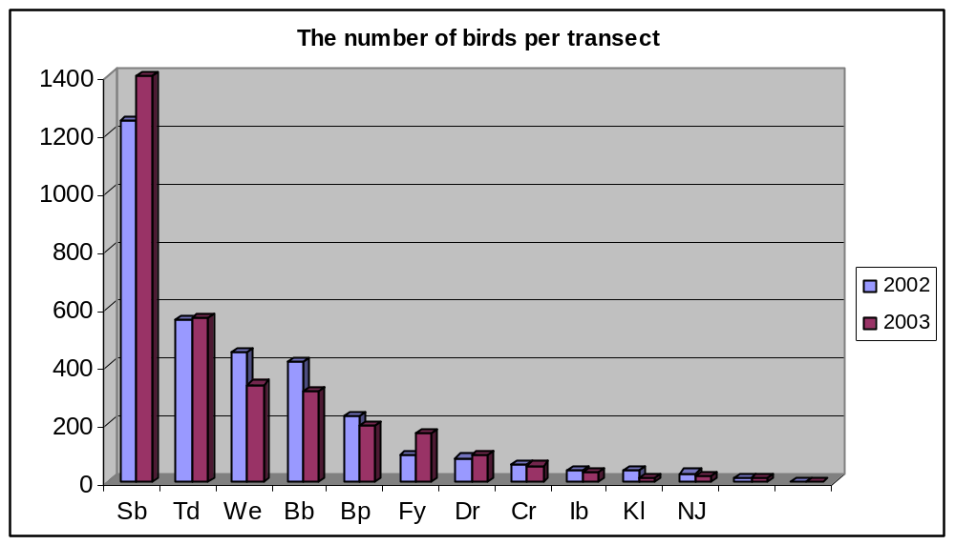
Figure 48: The total number of birds recorded on all the 7 transects during point counts in 2002 and 2003

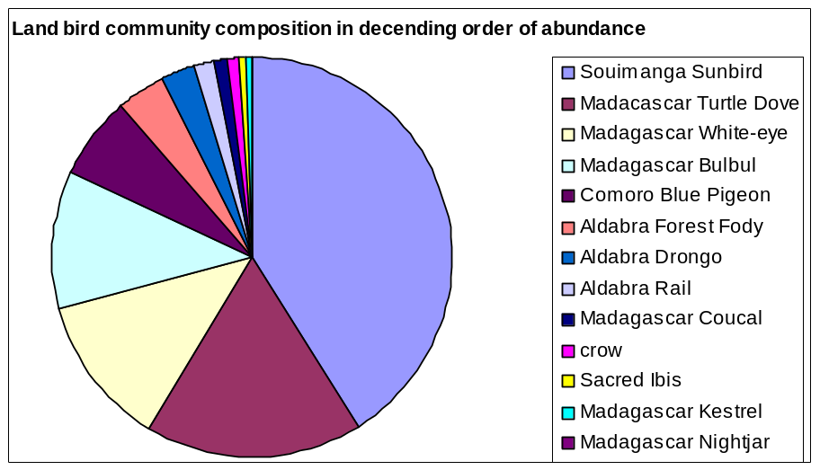
Figure 49: The proportion of each population of land bird species within the community as a whole.

4.1.1 The Souimanga sunbird (Nectarina sovimanga)
Being by far the most common land bird on Aldabra, the Souimanga sunbird feeds in a variety of habitats. A total of 2646 birds were recorded during point counts in 2002 and 2003.
A significant correlation was found between the two years (r²=0.78, p<0.01). Even though figure 50 suggests that the population is fairly equally dispersed over the 3 major vegetation types, it is evident from figure 51 that sunbirds seem to favour Grande Terre.
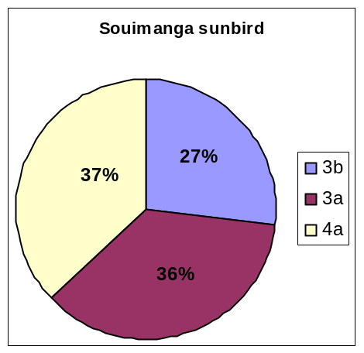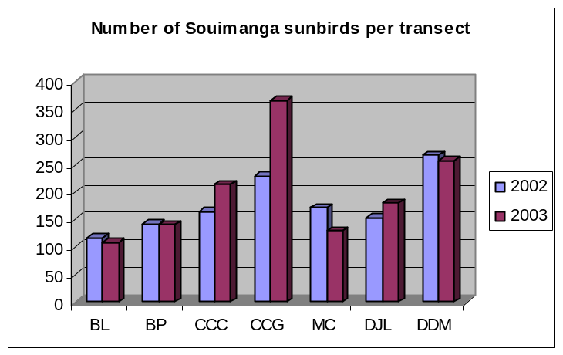
Figure 50: Habitat selection of the Figure 51: Number of Souimanga sunbirds per transect*
Souimanga sunbird∗

4.1.2 The Madagascar turtle dove (Streptopelia picturata)
A similar correlation between the two years to that of the Souimanga sunbird was found for the turtle dove (r²=0.76, p<0.01). Turtle doves seem to avoid Pemphis vegetation (figure 52). This is confirmed by the low number of sightings recorded on the DJL and DDM transects, both of which are dominated by Pemphis scrub. Turtle doves feed mainly on seeds and fruit and these are obviously fairly scarce in vegetation dominated by Pemphis.
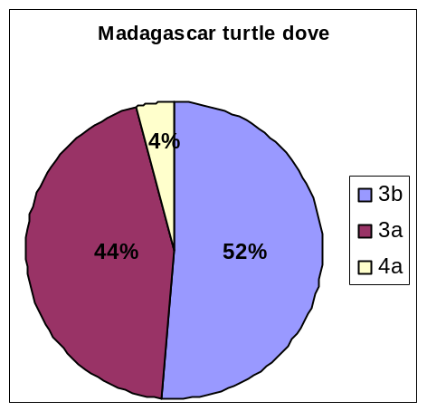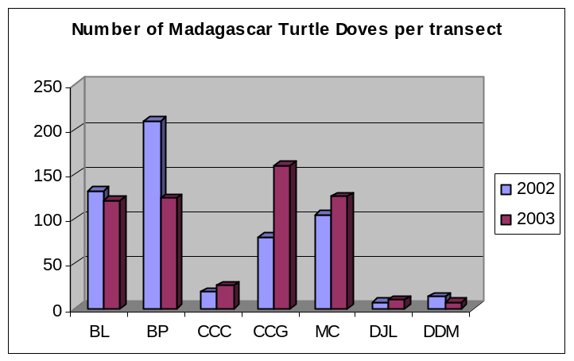
Figure 52: Habitat selection of the Figure 53: Number of Madagascar turtle dove per transect*
Madagascar turtle dove*

4.1.3 The Madagascar white-eye (Zosterops maderaspantana)
A similar correlation between years to that of the latter two species was evident (r²=0.76, p<0.01). In contrast to the turtle dove, white-eyes are readily found in Pemphis associated vegetation. This accounts for the high number of white-eyes recorded at DDM. White-eyes feed mainly on the small insects which abound in Pemphis scrub
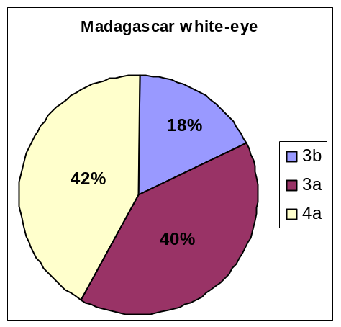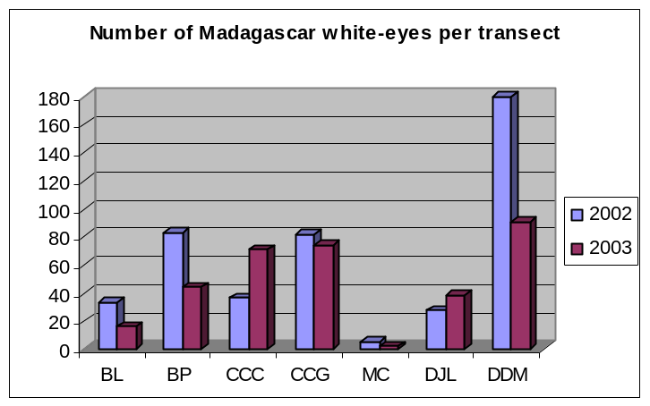
Figure 54: Habitat selection of the Figure 55: Number of Madagascar white-eyes per transect*
Madagascar white-eye∗

4.1.4 The Madagascar bulbul (Hypsipetes madagascariensis)
No significant correlation was found between 2002 and 2003. Total sighting amounted to 412 and 315 birds in 2002 and 2003 respectively with significant variation between areas in opposing years. These variations may be as a result of the habits of these birds as they seem to vary the extent of their activities throughout the day. Dawn seems to be their most active time and as the counts cannot always be done at this time, the data should show a higher degree of variance than other birds. Bulbuls feed on a selection of foods and are mostly seen in “Open mixed scrub” habitat.
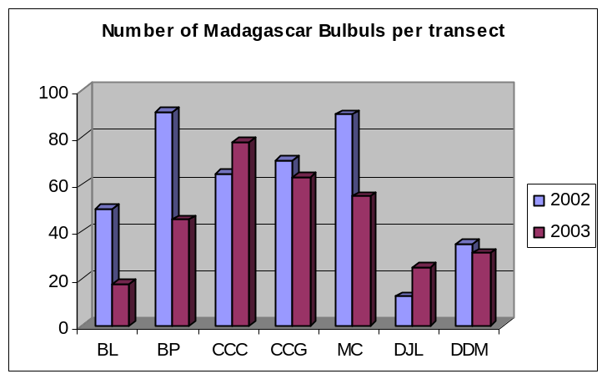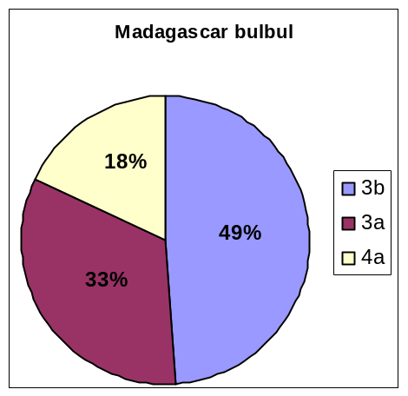
Figure 56: Habitat selection of the Figure 57: Number of Madagascar bulbuls per transect*
Madagascar bulbul*

4.1.5 Comoro blue pigeon (Alectroenas sganzini minor)
A highly significant correlation exists between the two years (r²=0.59, p<0.001). Blue pigeons show a high affinity for the “open mixed scrub” vegetation and are only ever recorded as ‘flying over’ Pemphis scrub. Large numbers are usually observed perching in trees along the MC transect which consists almost exclusively of “open mixed scrub”. Blue pigeons are often observed in mangrove stands and, as no mangrove habitat is included in any of the land bird points, habitat selectivity is poorly portrayed. 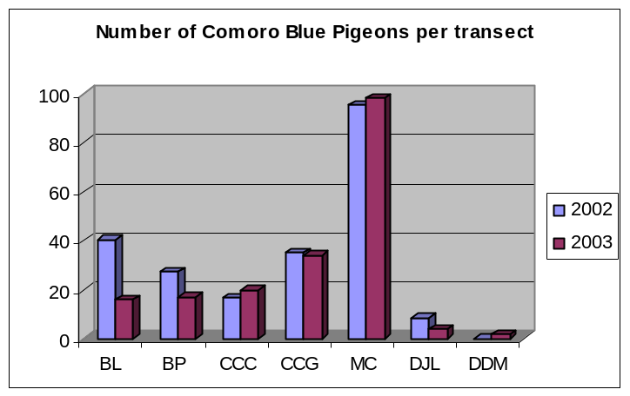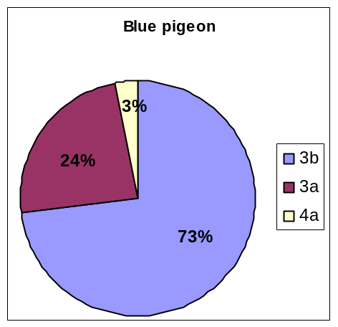
Figure 58: Habitat selection of the Figure 59: Number of Comoro blue pigeons per transect*
Comoro blue pigeon∗

4.1.6 The Aldabra fody (Foudia aldabrana)
A total of 90 and 167 sightings were made in 2002 and 2003 respectively. A highly significant correlation between the two years of data shows that the increase in numbers in 2003 is evenly distributed throughout its range (r²=0.94, p<0.001). Very few sightings were recorded in the “standard mixed scrub”. None of the land bird points are situated within Casuarina groves, and seeing that this is a favourite feeding ground for these gregarious birds, the habitat selectivity of fodies is not accurately portrayed.
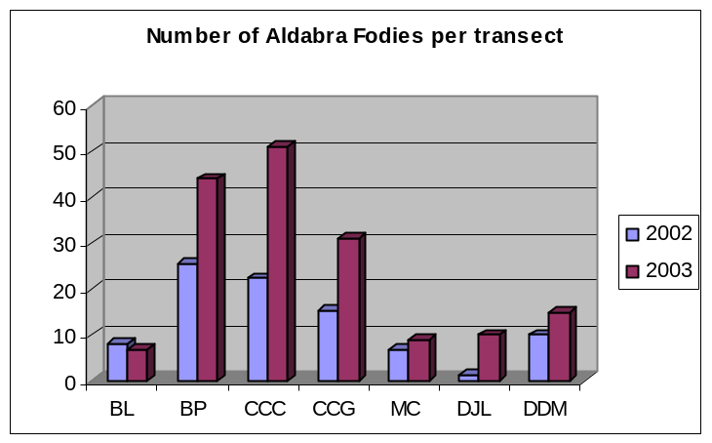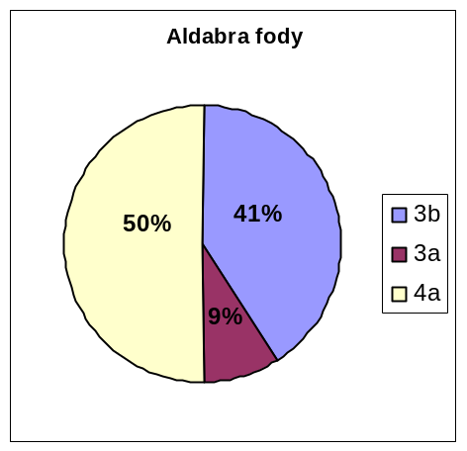
Figure 60: Habitat selection of the Figure 61: Number of Aldabra fodies per transect*
Aldabra fody*

4.1.7 The Aldabra drongo (Dicrurus aldabranus)
Even though the number of annual sightings is fairly low, a very significant correlation between 2002 and 2003 was found (r²=0.95, p<0.001). In many instances (especially on the back path) the same birds are seen during consecutive counts. Once again, a lack of the preferred tall, woody vegetation types in the selection of current land bird points has resulted in a poor representation of habitat selectivity.
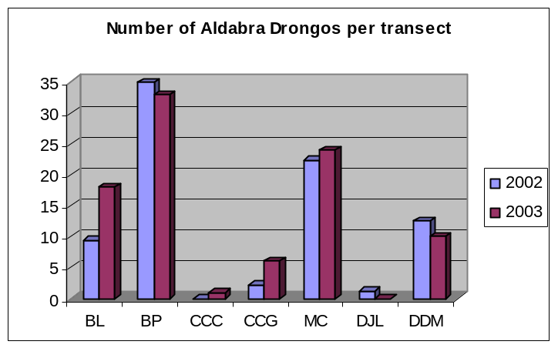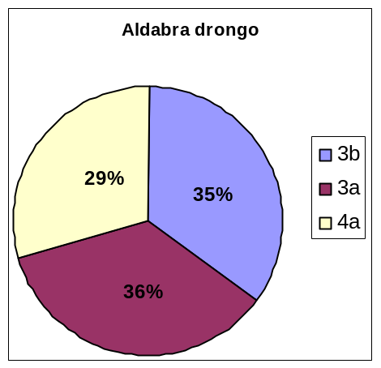
Figure 62: Habitat selection of the Figure 63: Number of Aldabra drongos per transect*
Aldabra drongo∗

4.1.8 The Aldabra rail (Dryolimnas aldabranus)
A more complete analysis of rail numbers can be viewed in section 4.2. A very strong correlation coefficient between 2002 and 2003 was found (r²=9.9, p<0.0001) the significance of which may be attributed to territoriality. No significant change in numbers was found. It is well known that rails utilize a variety of habitat and feed on an equally wide variety of food.
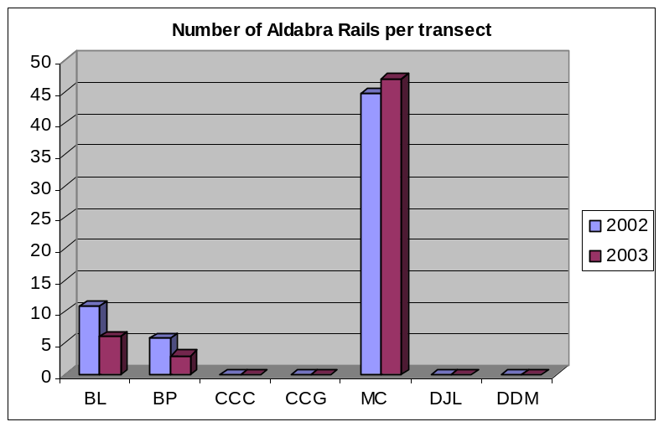
Figure 64: The number of Aldabra rails per transect

4.1.9 The Madagascar Coucal (Centropus toulou insularis)
A significant correlation was found between the two years (r²=0.72, p<0.01). Coucals prefer thick vegetation in which they hunt lizards and insects by running along branches. This accounts for the high percentage of sightings in the Pemphis scrub. However, the selection of current land bird points represents actual habitat selectivity unsatisfactorily.
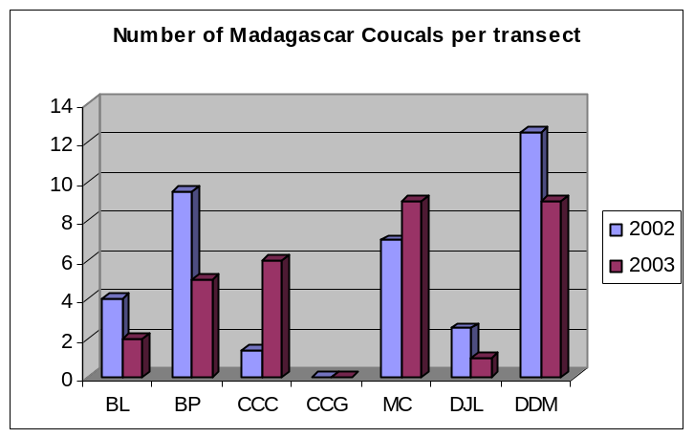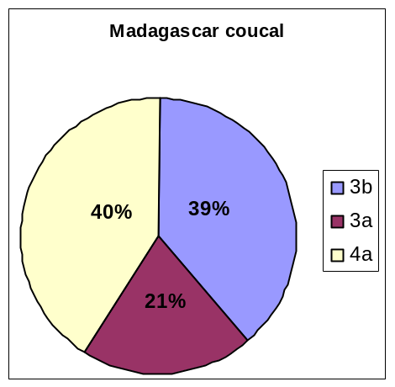
Figure 65: Habitat selection of the Figure 66: Number of Madagascar Coucals per transect*
Madagascar coucal∗

4.1.10 The Pied crow (Corvus albus)
Very few sightings of crows were recorded during point counts. The crows on Aldabra are extremely wary of humans and move away immediately when approached. Crows are gregarious and are very seldom seen on their own. The largest populations exist at the station on Picard and at Dune Jean Louis on Grande Terre. However, sightings have been recorded all over the atoll, especially along beaches exhibiting high turtle nesting activities. As many as 40 crows have been seen on the beach at DJL. An inspection of faeces at DJL suggests that the larger proportion of their diet consists of turtle hatchlings. Around the station, crow numbers seem to have abated slightly in response to the strict enforcement of policy regarding the disposal of waste food. All waste food is disposed of in the sea where the crows cannot benefit from it. It cannot be disputed that a large number of turtle and tortoise hatchlings are lost to crows. The controversy surrounding the classification of pied crows in Aldabra’s ecosystem deserves a detailed study (see recommendations).

4.1.11 The Madagascar sacred ibis (Threskiornis bernieri)
Owing to the infrequent recording of this species, no significant deductions can be made from the results. The correlation co-efficient between numbers in the years 2002 and 2003 is poor (r²=0.02). It must be noted however that no sightings of ibises have been made in vegetation type 4a. Ibises prefer the “open mixed scrub (3b)” where they feed on a variety of fauna including crabs, carrion and insects (figure 67).
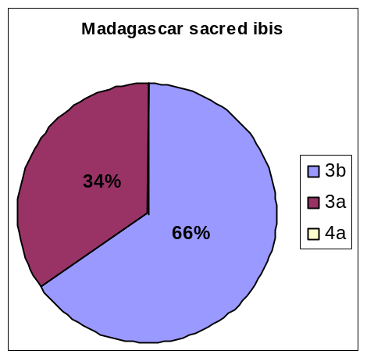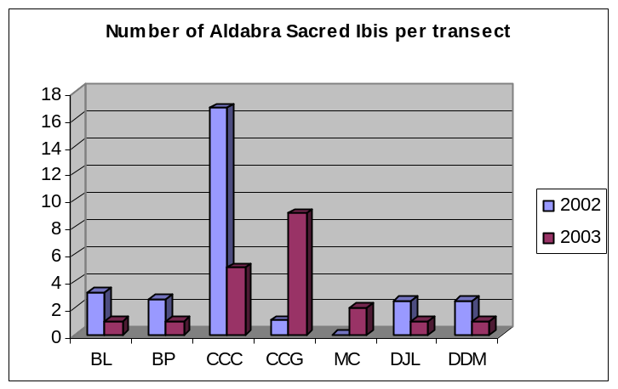
Figure 67: Habitat selection of the Figure 68: Number of Madagascar sacred Ibises per transect*
Madagascar sacred ibis

4.1.12 The Madagascar kestrel (Falco newtoni)
A total of 14 and 11 sightings were recorded in 2002 and 2003 respectively. These figures are too low for any form of analysis. Sightings were recorded on the following transects; Dune d’Messe, Dune Jean Louis, Middle camp and the back path on Picard.

4.1.13 The Madagascar nightjar (Caprimulgus madagascariensis)
Only three nightjar sightings were recorded during point counts. Nesting activities of a known individual at LaGigi were monitored. One egg was found in the month of October. After hatching, the mother moved the chick a few metres away from the nest and then continued to move it about on a daily basis, never moving away further than a few meters from the original nesting site. The chick became mobile within about 2 weeks of hatching at which time it was already capable of short bursts of flight.

4.1.14 Recommendations
- It is recommended that additional monitoring points should be allocated to the current program. These points should be selected such that each of the 17 vegetation types are well represented (a minimum of 5 points per vegetation type). The points should be established on Picard Island in order to prevent the dependability on tides to go elsewhere. The additional points will serve to clearly define habitat selectivity in land birds. The accurate determination of habitat selectivity is vital baseline information that can be used in future species specific studies.
- A method of monitoring pied crow numbers should be devised and should be advertised as a separate project for a graduate student.

4.2 Aldabra rail monitoring
In the past, rail monitoring transects were not conducted according to any temporal pattern as is evident from the database. Following my appointment, it was decided to conduct each transect on a monthly basis. However, this practice was abandoned after the month of May and replaced with a tri-monthly schedule. The reasoning of this change was based on the opinion that the rails were becoming indifferent to the repetitive procedure of responding to calls generated by the tape. During May of this year, rails that were already on site before the tape was played showed absolutely no response to the tape recordings. Mr Ross Wanless was consulted on this matter and indicated that transects should be conducted less frequently.
The possibility that rails only respond to the recordings on a seasonal basis was examined by conducting an analysis of the 2001 and 2002 data. No significant seasonal correlations in rail numbers were found, thereby discounting such a possibility.
Owing to the high degree of variance in the quantity of sightings over the three years, the monitoring method is not effective when attempting to estimate population sizes or trends. It is highly unlikely that the totals depicted in tables 23-26 have any bearing on actual population sizes. However, it is unlikely that any other method employed in place of the current ‘Huxley’ method will yield better results. Aldabra rails are very diverse in character and behave in an unpredictable manner. Sometimes birds rush up to the tape player and peck at it, other times they don’t pay any attention to our efforts at deceiving them. With the latter in mind and the additions of other factors such as small population size, territoriality and the effect of strong wind on the audibility of the recording, there are too many variables involved and it is highly unlikely that meaningful population data will ever be generated.
At the most, it may be deduced on which transects rails are the most common; the Middle Camp transect seems to support the highest frequency of sightings annually.

The Picard rail population seems to be stable even though no sound data has been collected to substantiate this statement. In January this year, several chicks were sighted. Territories around staff housing seem to be in great demand and the rails are often found challenging each other in fierce combat. This may due to small food scraps found in the staff houses, rails also often seek shelter from each other in staff housing and feed on insects such as spiders and dead flies.

Some rails were found to be in discomfort as a result of their rings. The rings seem to be a little too loose as one individual was seen with a stick firmly wedged between the ring and its leg (the stick dislodged itself after a few days) and a few others were seen limping in favour of the un-ringed foot. In the future, any birds seen suffering due to their rings will be caught and the ring removed.

4.2.1 The Middle camp transect
The Middle camp transect consists of 13 points. The number of birds sighted annually since 2001 has been fairly stable (table 23). A total of eleven different ringed birds were encountered, with varying degrees of occurrence, over the period in question (see appendix 4). Three ringed pairs were identified of which W30&W31 were observed most often. This pair has been following a seemingly monogamous lifestyle over the last three years and was observed with 2 chicks in February this year.

Table 23: Number of birds recorded along the Middle camp rail monitoring transect in the last three years (X= not completed)
Month | 2001 | 2002 | 2003
January | X | X | 8
February | X | 18 | 8
March | X | X | 5
April | X | X | 14
May | 15 | X | 10
June | 7 | X | X
July | X | 6 | X
August | 11 | 6 | 7
September | X | 2 | X
October | 10 | X | X
November | X | 7 | 4
December | 7 | 15 | X
Transects completed | 5 | 6 | 7
Total sightings | 50 | 54 | 56

4.2.2 The Malabar transect
Numbers along the Malabar transect seem to be stable (Note that the increase in numbers is as a result of the increased number of completed transects each year –table 24). No birds have been ringed along this transect in the past. He transect consists of 20 points.

Table 24: Number of birds recorded along the Malabar rail monitoring transect in the last three years (X= not completed)
Month | 2001 | 2002 | 2003
January | X | X | 10
February | X | 12 | 3
March | X | X | 7
April | X | X | 10
May | X | X | 13
June | 4 | X | X
July | X | X | X
August | 6 | 2 | 3
September | X | X | X
October | 5 | 3 | X
November | X | 8 | 7
December | 16 | 18 | X
Transects completed | 4 | 5 | 6
Total sightings | 31 | 43 | 53

4.2.3 The Gionnet transect
The number of sightings along the Gionnet transect have been highly variable over the years. The increased variance may be partly attributed to the insufficient number of 9 points. A surprisingly low number of 7 birds were recorded in 2002 (table 25).
Five pairs of ringed birds were observed over the years (appendix 4), it is interesting to note that rail W12 was seen with W14 in May of 2001 and was subsequently recorded again with W47 just one month later. This fact casts some doubt on the hypothesis that rails are strictly monogamous. This fact is further supported by the observations of Guy Esparon on Picard (pers. comm.). On several occasions, rails that were thought to have been permanently paired were observed “swapping partners”.

Table 25: Number of birds recorded along the Gionnet rail monitoring transect in the last three years (X= not completed)
Month | 2001 | 2002 | 2003
January | X | X | 3
February | X | X | 1
March | X | 4 | X
April | X | X | 6
May | 11 | 1 | 6
June | 7 | X | X
July | X | 0 | X
August | 5 | X | 2
September | X | 1 | X
October | 3 | 1 | X
November | X | X | 2
December | 3 | X | X
Transects completed | 5 | 5 | 6
Total sightings | 29 | 7 | 20

4.2.4 The Polymnie transect
Significant variances in annual numbers were computed.
Two pairs of ringed birds were observed during the period in question. Of these 2 pairs, W23&W26 were seen most often. In January 2003 they were seen with 2 young chicks.

Table 26: Number of birds recorded along the Polymnie rail monitoring transect in the last three years (X= not completed)
Month | 2001 | 2002 | 2003
January | X | X | 9
February | X | 5 | 0
March | X | X | X
April | X | X | 12
May | 7 | X | 19
June | 3 | X | X
July | X | 12 | X
August | 6 | 1 | 3
September | 5 | 2 | X
October | X | 2 | X
November | X | X
December | 13 | 6 | X
Transects completed | 5 | 6 | 6
Total sightings | 34 | 28 | 43

4.2.5 Recommendations
- The design of a new monitoring program to detect trends in the Picard rail population is required. In the past it was attempted to keep the entire area around the station under observation for evidence of nesting and nesting success. This is a full-time job in itself and the variability of effort in this regard is not subject to continuity. Perhaps a new rail transect could be designed on Picard in accordance with the other transects across the atoll. The length of the Picard transect should be such as to detect outward movement of birds in seek of new territories. The establishment of new territories could prove a useful indicator of population growth.

4.3 Wader counts
As a new addition to the long term monitoring program for birds on Aldabra, wading species have been counted along predetermined sections of shore-front on Picard and Grande Terre. The Picard transect incorporates the area between the old cemetery and the new boat shed at LaGigi. Birds are counted by a minimum of two rangers and counts are always conducted at low tide. The transect on Grande Terre includes the region between Dune Jean Louis and Dune D’Messe and is conducted in combination with the monthly track count. Unfortunately bird counts in this region could not be completed every month due to tide restrictions. The surveyor is limited to conducting the 2 hour walk in the morning due to the heat and the need to conduct track counts as early as possible.

Table 27: Waders counted on Grande Terre in 2003
Species | 27/1/2003 | 30/7/2003 | 27/8/2003 | 12/11/2003
Egret, dimorphic | 74 | 8 | 2 | 4
Heron, green-backed | 5 | 1 | 0 | 0
Heron, grey | 5 | 8 | 2 | 2
Plover, crab | 80 | 0 | 0 | 262
Plover, grey | 2 | 0 | 8 | 0
Sandplover, greater | 6 | 0 | 0 | 300
Tern, black-naped | 4 | 0 | 1 | 0
Tern, caspian | 1 | 0 | 0 | 0
Turnstone | 73 | 5 | 14 | 100
Whimbrel | 4 | 0 | 13 | 2

Table 28: Waders counted on Picard in 2003
Species | 13/5/2003 | 2/6/2003 | 24/7/2003 | 20/8/2003 | 22/9/2003 | 7/10/2003 | 4/11/2003
Egret, dimorphic | 127 | 100 | 28 | 10 | 18 | 38 | 111
Heron, green-backed | 5 | 9 | 7 | 4 | 2 | 1 | 5
Heron, grey | 5 | 2 | 7 | 9 | 5 | 7 | 4
Godwit, bar-tailed | 0 | 0 | 0 | 0 | 0 | 0 | 11
Greenshank | 0 | 0 | 0 | 0 | 15 | 15 | 2
Plover, crab | 14 | 0 | 1 | 4 | 0 | 1 | 62
Plover, grey | 1 | 0 | 0 | 1 | 7 | 0 | 8
Sanderling | 0 | 3 | 0 | 0 | 1 | 0 | 10
Sandpiper, curlew | 0 | 0 | 0 | 0 | 1 | 6 | 3
Sandplover, greater | 0 | 2 | 0 | 0 | 5 | 0 | 0
Sandplover, lesser | 0 | 0 | 1 | 0 | 0 | 0 | 7
Tern, black-naped | 0 | 0 | 3 | 0 | 0 | 3 | 0
Tern, caspian | 0 | 0 | 2 | 6 | 1 | 3 | 0
Tern, greater crested | 10 | 5 | 0 | 2 | 3 | 2 | 6
Turnstone | 6 | 17 | 5 | 29 | 50 | 55 | 110
Whimbrel | 4 | 1 | 0 | 7 | 5 | 3 | 6

4.4 Rare sightings
Rare bird sightings are listed in appendix 5. In addition to the listed birds, a pratincole of uncertain species was found feeding on insects on the beach at the old cemetery on Picard.

 3b= Open mixed scrub BL= Bassin Lebine CCG= Cinq cases groves DDM= Dune D’Messe 3a= Standard mixed scrub BP= Back Path MC= Middle camp 4a= Pemphis dominant scrub CCC= Cinq cases coco DJL= Dune Jean Louis
 3b= Open mixed scrub BL= Bassin Lebine CCG= Cinq cases groves DDM= Dune D’Messe 3a= Standard mixed scrub BP= Back Path MC= Middle camp 4a= Pemphis dominant scrub CCC= Cinq cases coco DJL= Dune Jean Louis
 3b= Open mixed scrub BL= Bassin Lebine CCG= Cinq cases groves DDM= Dune D’Messe 3a= Standard mixed scrub BP= Back Path MC= Middle camp 4a= Pemphis dominant scrub CCC= Cinq cases coco DJL= Dune Jean Louis
 3b= Open mixed scrub BL= Bassin Lebine CCG= Cinq cases groves DDM= Dune D’Messe 3a= Standard mixed scrub BP= Back Path MC= Middle camp 4a= Pemphis dominant scrub CCC= Cinq cases coco DJL= Dune Jean Louis
 3b= Open mixed scrub BL= Bassin Lebine CCG= Cinq cases groves DDM= Dune D’Messe 3a= Standard mixed scrub BP= Back Path MC= Middle camp 4a= Pemphis dominant scrub CCC= Cinq cases coco DJL= Dune Jean Louis

